***Directions: Provide a snippet of each figure in the tutorials below.***

**Tutorial 4-1 (Pg. 238):**

1. Figure 4-5:

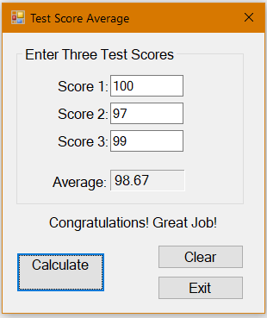

**Tutorial 4-2 (pg. 242):**

1. Figure 4-7:

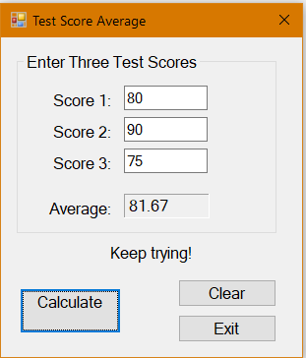

**Tutorial 4-3 (pg. 245):**

1. Figure 4-10:

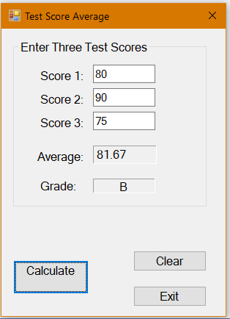

***Continuation of Snippets:***

**Tutorial 4-4 (pg. 251):**

1. Step 5:

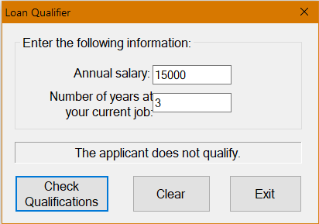

**Tutorial 4-5 (pg. 262):**

1. Step 8:

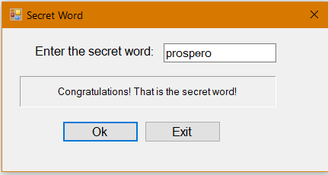

**Tutorial 4-6 (pg. 267):**

1. Step 4:

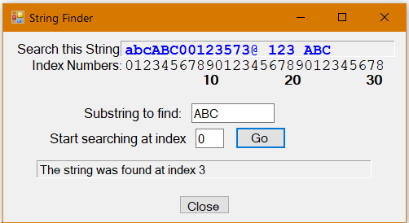

***Continuation of Snippets:***

**Tutorial 4-7 (pg. 273):**

1. Figure 4-22:

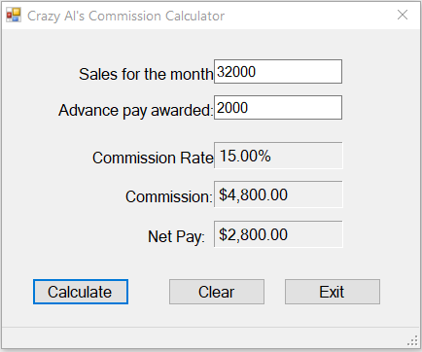

**Tutorial 4-8 (pg. 278):**

1. Step 4:

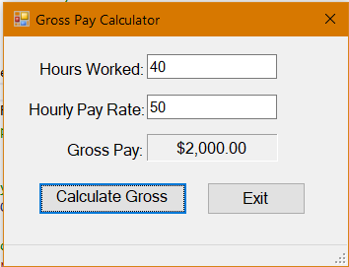

**Tutorial 4-9 (pg. 283):**

1. Step 5:

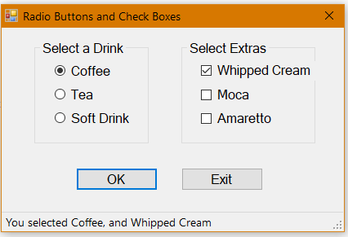

**Tutorial 4-10 (pg. 290):**

1. Step 7:

